**NATIONAL COLLEGE OF COMPUTER STUDIES**

**Tribhuvan University**

Institute of Science and Technology

Proposal

On

“Medical Alert System”

Submitted To  
**National College of Computer Studies (NCCS)**

**Paknajol, Kathmandu**

**Nepal**

Submitted By

**Inusha Pandey (NCCSCSIT311)**

**Shishir Regmi (NCCSCSIT334)**

**B.Sc. CSIT**

**7th Semester**

**December 27, 2022**

**Table of Contents**

1 Introduction 1

2 Problem Statement 1

3 Objective 2

4 Methodology 2

4.1 Related Works 4

4.2 Requirement Analysis 4

4.2.1 Functional Requirement: 5

4.2.2 Non-Functional Requirements 5

4.3 Feasibility study 5

4.3.1 Technical feasibility: 6

4.3.2 Economic feasibility: 6

4.3.3 Operational feasibility: 6

4.4 Data collection 6

4.5 Tools 7

4.5.1 Analysis and design tool 7

4.5.2 Implementation tools 7

4.5.3 Working Mechanism 7

4.5.4 Open Eye Detection for Patient Monitoring 8

4.5.5 Discomfort Detection for Patient Monitoring 9

4.5.6 Description of ‘Convolutional Neural Network’ Algorithm 10

4.5.7 Description of ‘Open CV’ 11

5 Expected Outcome 11

6 Working Schedule 11

References 14

# Introduction

Medical alert systems are designed to alert doctors or nurses in hospitals in case of emergencies such as sudden patient panics and similar other emergency situations. These systems can be very beneficial for saving the lives of numerous patients.

Patients are constantly monitored by the aid of various ICT Tools like cameras and sensors, and the patient situations are evaluated using algorithms which use the data from the ICT Tools. This information is examined to determine the possibility of an emergency occurring and to provide instant medical attention from the doctors.

Medical alert systems can be used for a variety of purposes, including:

* Providing warning alerts in case of patient panics
* Security can be provided by sending alert of unauthorized entry in patient’s room
* Special Patients can be monitored more easily
* Supporting research and understanding of patient patterns

Overall, Medical alert systems can play a vital role in the medical sector. It is important to carefully plan and design these systems, and to involve stakeholders in the process to ensure that they meet the needs and address the concerns of the community.

# Problem Statement

There are many patients in a hospital who need constant observation from the doctors. So a minute of delay of medical support can be life threatening to the patients. Also, there are cases of special wards where patients who are in special conditions are kept. An example can be of a Patient who is in a coma. So observing these kinds of patients by the doctors along with the use of ICT can be very beneficial for the patient’s quick recovery.

This problem statement identifies the benefits of having a computer aided monitor for the patients as even a single minute delay in medical attention can be life threatening to the patients. It also highlights the need for a more accurate and reliable medical alert system to provide early warning alerts and improve medical science.

# Objective

Here are some potential objectives for a medical alert system project:

* To provide fast warning alerts for patient’s potential problems.
* To monitor a patient's health.
* To keep a tab of a patient's past discomforts.
* To improve security in the patient's room.

# Methodology

A medical alert system is a system that is used to alert the patient's discomfort to the doctors as soon as possible. The methodology for a medical alert system will depend on the specific characteristics of the area in question, as well as the data and tools that are available for use in the monitoring process.

There are several key steps that are typically involved in the development of a medical alert system:

* Identify the possible patient discomforts and unusual activities
* Identify the study area
* Determine emergency criteria
* Create a working Prototype
* Validate the system
* Implement the system
* Maintain and update the system

To develop a medical alert system, it is important to consider the following factors:

* Data sources: The accuracy and reliability of the medical alert system will depend on the quality and availability of data sources. These may include data on human body movement, body parts like eyes, hands, mouth etc.
* ICT tools: The use of ICT Tools like cameras and sensors is absolutely necessary for the system. These tools are used to monitor the patient’s condition like hand movement, eye opening, panics etc.
* Data management and analysis: It is important to have a system in place for collecting, storing, and analyzing the data used in the medical alert system. This may include tools for data visualization, statistical analysis, and machine learning.
* Communication and dissemination: The medical alert system should have a system in place for communicating the results of the modelling and analysis to relevant medical personnel, such as doctors or nurses. This may include the use of alerts, graphs, and other audiovisual aids to communicate the results of the monitoring.

Regardless of the method used, the medical alert system should be regularly updated and tested to ensure its accuracy and effectiveness.

There are several different approaches to developing a medical alert system, depending on the specific context and needs of the community or region in question. Some common elements of a medical alert system may include:

Collection and analysis of data on patient patterns, video monitoring, body movements, and other factors that can impact the likelihood of an emergency. This data may be collected through a combination of camera imagery, motion sensors, and other sources.

Use of mathematical models and computer simulations to predict how different patient patterns and other factors may affect the likelihood of an emergency. These models may be based on patients' past data and may be adjusted over time as new data becomes available.

Development of warning systems to alert doctors in case of emergencies is imminent. These systems may include sirens, text alerts, or other methods of notification.

It is important to note that no medical alert system is foolproof, and that it is always important for doctors to be prepared for the possibility of an emergency, even in case the medical alert system cannot determine emergencies.

## Related Works

There has been a significant amount of research on medical alert systems in recent years. Some related works include:

* Pulse sensing: The Pulse Sensor is a plug-and-play heart-rate sensor for Arduino. It can be used by students, artists, athletes, makers, and game & mobile developers who want to easily incorporate live heart-rate data into their projects. The essence is an integrated optical amplifying circuit and noise eliminating circuit sensor. Clip the Pulse Sensor to your earlobe or fingertip and plug it into your Arduino, you can ready to read heart rate. Also, it has an Arduino demo code that makes it easy to use.
* LM35 Temperature Sensor: The LM35 series are precision integrated-circuit temperature devices with an output voltage linearly-proportional to the Centigrade temperature. The LM35 device has an advantage over linear temperature sensors calibrated in Kelvin, as the user is not required to subtract a large constant voltage from the output to obtain convenient Centigrade scaling. The LM35 device does not require any external calibration or trimming to provide typical accuracies of ±¼°C at room temperature and ±¾°C over a full −55°C to 150°C temperature range. [1]
* Contactless Body Temperature Monitoring: The proposed CBTM implementation applied artificial intelligence and Internet of Things (IoT) technologies. The specified infrared body temperature on the MLX90614 DCI used for the medical field was selected to embed the IoT-CBTM for IPD using the IoT platform. The MLX90614 is an accurate sensor that matches to use for medical promotion. The detected information data from IPD will be sent to the host computer and stored in the cloud internet service at a microwave band frequency of 2.5/5.0 GHz. [2]

## Requirement Analysis

We have broken our requirement analysis into two sections: Functional requirement and Non-Functional Requirement.

### **Functional Requirement:**

Functional Requirements defines what the system must do. It defines the behaviors or functions of a system, flows and other requirements of a system along with its output. Functional requirements may be calculations, technical details, data manipulation and processing and other specific functionality that define what a system is supposed to accomplish. Behavioral requirements describing all the cases where the system uses the functional requirements are captured in use cases. Functional requirements are supported by non-functional requirements (also known as quality requirements), which impose constraints on the design or implementation (such as performance requirements, security, or reliability). Our software will be fully-responsive web application, meaning no user should deflect on using our application due to device barriers. It runs responsively on PC.

1. **Non-Functional Requirements**

It defines how the system should be. A non-functional requirement is a requirement that specifies criteria that can be used to judge the operation of a system, rather than specific behaviors. They are contrasted with functional requirements that define specific behavior or functions.

1. Scalability: Our system is scalable as this application will go beyond a college project for which necessary actions like upgrading server, creating a team, will be taken care of.
2. Maintainability: The application will be very easy to maintain as a detail documentation will be prepared describing all the components used in the system. This ensures that the future software developers and engineers will have no difficulty in securing the quality of our application.
3. Usability: Our website is simple to use which makes accessing desire feature a lot easier and faster. Every UI component are arranged properly for easy navigation and effective usage of the website.

## Feasibility study

A feasibility study is an assessment of the practicality of a proposed plan or project. A feasibility study analyzes the viability of a project to determine whether the project or venture is likely to succeed.

 A feasibility study of a medical alert system would consider a number of factors, including:

### **Technical feasibility:**

Medical alert systems involve constant monitoring of patients for which various ICT tools are required. After setting up once everything is automated and we can easily get the required data and can implement appropriate algorithms for medical alert system. So the project is technically feasible to do.

### **Economic feasibility:**

The main function of this medical alert systems is to detect patient discomfort and give a notification about it. To do so, we need Sensors and Cameras. It costs the minimum to collect the required tools and implement it with appropriate algorithm for Hospitals. Thus developing and maintaining the medical alert system is economically feasible.

### **Operational feasibility:**

Medical alert system is practical to operate and maintain over the long term. The models and algorithms used to analyze and interpret the rain data are accurate and reliable so that the doctors and nurses can be alerted in time. Thus, it is operationally feasible.

The System UI is basic and one can quickly learn to operate it.

Thus, from various feasibility studies we came to know that the “Medical alert system” is feasible to do.

## Data collection

Past data can be collected from a variety of sources. A suitable dataset can be surfed from internet and suitable ML algorithm can be implemented so that our own custom data can be inserted. It is important to ensure that the data is accurate and up to date in order to improve the accuracy of the patient’s condition.

## Tools

### **Analysis and design tool**

|  |  |
| --- | --- |
| Tools | Specifications |
| Programming Languages | JavaScript, Python , .NET core,  C++ |
| Database | MySQL |
| UI/UX | Adobe XD, Figma |
| Documentation | Microsoft Office Package |
| Other tools | Adruino |

Table 1 Analysis and Design tools

### **Implementation tools**

Front end: HTML, CSS, JavaScript

Back end: Python, .Net core

### **Working Mechanism**

The application is layered on top of eye detection and movement detection mechanism which checks if the patient is awake or in some unwanted situation.

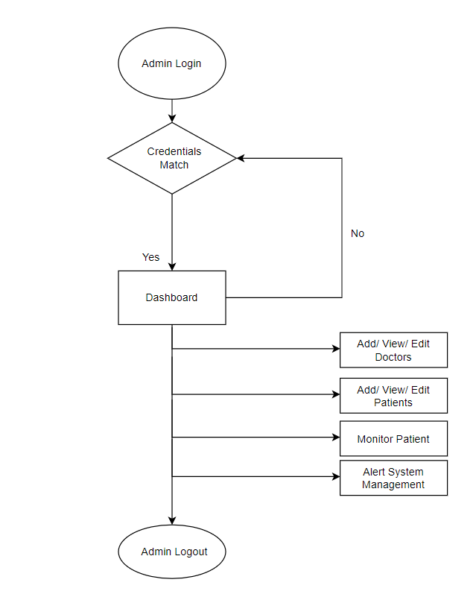

Figure 1 Proposed System Diagram

As shown in the figure above, the admin gets to access the system and s/he is responsible for the updating the information of doctors and patients. Admin is also responsible of monitoring the patient.

### **Open Eye Detection for Patient Monitoring**

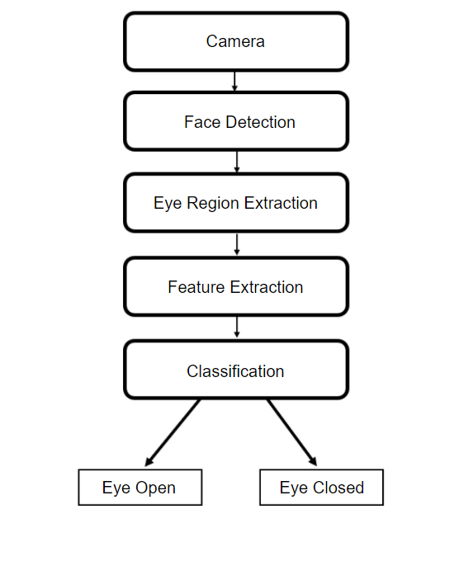

Figure 2 Diagrammatic Representation of Open Eye Detection

### **Discomfort Detection for Patient Monitoring**

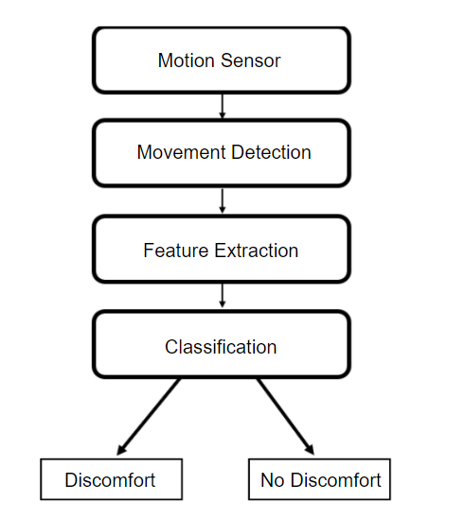

Figure 3 Diagrammatic Representation for Discomfort detection

### **Description of ‘Convolutional Neural Network’ Algorithm**

Convolutional Neural Network (CNN) is a type of multilayer neural network containing two or more hidden layers. The hidden layers mainly perform two different kinds of functions:

* Convolution: Using multiple filters, it is able to extract features (feature map) from the data set, through which their corresponding spatial information can be preserved.
* Pooling: Also called subsampling, it is used to reduce the dimensionality of feature maps from the convolution operation.

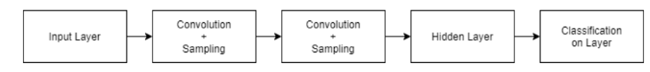

Figure 4 CNN Structural Diagram

The proposed CNN consists of 3 stages:

1. First stage produces a candidate windows quickly through a shallow CNN.
2. Then, it refines the windows to reject a large number of non-faces windows through a more complex CNN.
3. Finally, it uses more powerful CNN to refine the result and output facial landmarks positions.

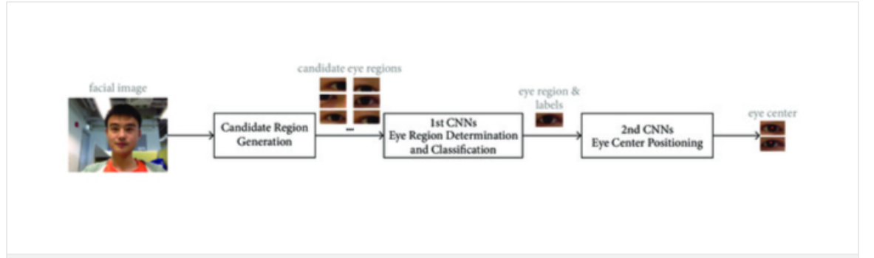

Figure 5 Use of CNN in Eye Detection

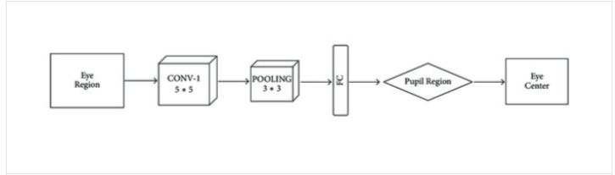

Figure 6 Structure of 2nd CNN

### **Description of ‘Open CV’**

OpenCV is an open-source software library for computer vision and machine learning. The OpenCV full form is Open Source Computer Vision Library.

The eye-detection algorithms focus on the detection of the frontal human eye. The Python OpenCV library functions are mainly aimed at real-time computer vision. It is mainly used to do all the operations for image processing as well as detect objects. OpenCV already contains many pre-trained classifiers for faces, eyes, smiles, etc.

# Expected Outcome

Once the project development gets completed, our application will obtain for following

major outcomes:

* A responsive web-application that runs seamlessly with eye and movement detection module.
* Safe platform that verifies if any patient needs immediate care.

# Working Schedule

This project is expected to complete in the given time frame provided by our university. As the project is complex and given the time period for its development, we have divided the development process into three phases:

* **Phase One:**

This phase is all about project planning and research and creating a layout for software blueprint. We will work on following sections in this phase:

1. Defining Project Timeline
2. Research on Software Feature
3. Writing Proposal
4. Interface Design/Flow Charts
5. ER/DFD Designs
6. UML Diagrams

* **Phase Two:**

Here we will start on actual app development alongside the final documentation and report for the project. This phase includes:

1. Frontend/Backend Development
2. Documentation/Final Report Draft

* **Phase Three:**

This is the final and most important part of our project. Here we will work on integrating our main feature and validating eye and movement detection module. We will work on increasing our accuracy, hence defining the importance of this phase for this project. Our list includes:

1. Features Integration
2. Modules Validation
3. Major System Testing
4. Final Report Documentation

These phases are represented figuratively using a Gantt chart in the next page. The project workflow might change but the overall skeleton and datelines will remain intact throughout the development process.

|  |  |  |  |
| --- | --- | --- | --- |
| **Task** | **Start Date** | **End Date** | **Days to Complete** |
| **Planning** | 27-Dec | 28-Dec | 2 |
| **Study and Analysis** | 29-Dec | 8-Jan | 9 |
| **Data Collection** | 9-Jan | 12-Jan | 2 |
| **Coding and Implementation** | 13-Jan | 4-Feb | 22 |
| **Testing** | 5-Feb | 9-Feb | 4 |
| **Documentation** | 10-Feb | 16-Feb | 6 |
| **Review** | 17-Feb | 20-Feb | 3 |
| **Presentation** | 21-Feb | 21-Feb | 1 |

Table 2 Working Schedule

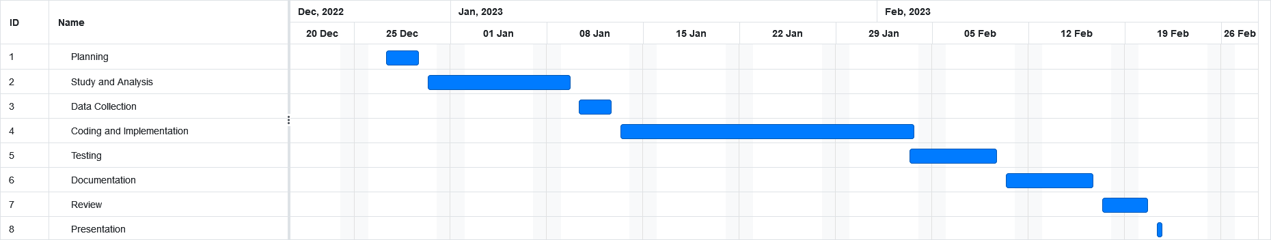

Figure 7 Gantt chart

# References

[1] A. Newton, “IoT Based Patient Health Monitoring using ESP8266 & Arduino,"

HowToElectronics, 2022.

[2] National Library of Medicine, "Contactless Body Temperature Monitoring of In-Patient Department (IPD) Using 2.4 GHz Microwave Frequency via the Internet of Things (IoT) Network," PubMed, 2022.